RILEM INTERNATIONAL CONFERENCE ON SUSTAINABLE MATERIALS, SYSTEMS AND STRUCTURES
First A. Author (1), Second B. Coauthor (2) and Third C. Coauthor (2)
(1) Northwestern McCormick School of Engineering, USA
(2) Faculty of Civil Engineering, University of Zagreb, Croatia

Abstract
This document provides information and instructions for preparing a paper to be included in the Proceedings of the RILEM SMSS Conference. The paper has to be saved as .doc/docx file. Papers will appear in print exactly as they have been prepared by the author. Therefore, it is essential that the paper be accurately and attractively presented.
The first page starts with the title of the paper, the authors, affiliation and keywords. The abstract should be less than 200 words.
All the instructions as well as the source for the example can be found in the web page of the Conference http://grad.hr/rilem.smss/call-for-papers/#submit The paper should be written following the format of Word template for submission that can be found in that address. The organizers do not commit themselves to include in the Proceedings any paper received in different formats and received later than the deadline for full paper submission.

Keywords: max 5 keywords

1. Introduction
Authors should submit the paper electronically in Word format latest by 1st October 2018, through the website of paper submission system
http://grad.hr/rilem.smss/ocs/index.php/smss/smss
The organizers do not commit themselves to include in the Proceedings any paper received later than the above-mentioned deadline. At least one of the authors must register and pay the registration fee during the early-bird period (before 30 November 2018) for their paper to be included in the final programme of the Conference and in the Proceeding. One registered participant can present maximum 2 papers. If other co-authors plan to participate in the conference, they need to register as well.

2. General specifications
The paper must be written in good English. All text including tables and graphics must fit into a printing box of 16 cm x 22.5 cm on A4 type paper, 2.5 cm left margin and 3.6 cm top margin (right and bottom margins adjusted for A4), Times New Roman font (also for font used in Excel charts, diagrams or figures). No part of the paper to be reproduced should appear out of the printing box. The final pages of the proceedings will be reproduced at a factor size of 0.8, thus resulting in a final printing area of 12.8 cm x 18.0 cm. The authors should pay attention to the thickness of lines in graphics, which should not be less than 0.15 mm at the final size of the paper, for being visible in the final pdf file, used for printing the proceedings. The paper including figures, tables and references must have a minimum length of 4 pages and must not exceed 8 pages.

3. Title, authors, affiliation
The page one of the paper starts with the title of the paper, the authors, affiliation, the Abstract and keywords. The first line of the title is located 2 cm (60 points) from the top of the printing box.

3.1 Title
The title should be written left aligned, in 14 pt, boldface Times New Roman, all capital letters. It should be single spaced if the title is more than one line long.

3.2 Author (s)
The author's name should include first name, middle initial and surname. It should be written left aligned, in 12 pt boldface Times (New) Roman, 12 pt below the title.

3.3 Affiliation
Author's affiliation should be written left aligned, in 12 pt Times New Roman, 12 pt below the list of authors. A 12 pt space should separate two different affiliations.

3.4 Abstract
Use 12 pt Times New Roman for the abstract. The word Abstract must be set in Times New Roman 12 boldface, not italicized. The abstract text should be justified and separated 12 pt from the keywords, as shown in the previous page of these instructions. The abstract should neither be too short nor exceed the first page of the paper.

4. Headings

4.1 Main headings
The main headings should be written left aligned, in 12 pt, boldface in capital. There should be a 12 pt space before and 6pt after the main headings.

4.2 Secondary headings
Secondary headings should be written left aligned, 12 pt, boldface Times New Roman, with an initial capital for first word only. There should be a 12 pt space before and 0 pt after the secondary headings.

5. Text
The normal text should be written single-spaced, justified, using 12 pt Times New Roman in one column. The first line of each paragraph must be indented 0.5 cm. There is not inter-paragraph spacing.

6. Page numbers
In case a digital version of the Proceeding is prepared, a paper will be found by the author's name or using the keywords. Page numbering is unnecessary for this purpose. However in any case, in order to organize the paper and for final control, it is requested to number the pages. Write the page number right aligned at the bottom of each page, with 12 pt Times New Roman.

Note: Page numbers are not included in the printing box.

7. Tables
Keep tables simple. Range tables and table headings left. Do not spread tables out across the page. Type the table number and title immediately above the table. All tables should be numbered consecutively and captioned, the caption should be 12 pt Times (New) Roman, upper and lower case letters.

Table 1: Example of construction of a table
C11 | C12 | C13
C21 | C22 | C23
C31 | C32 | C33
C41 | C42 | C43
C51 | C52 | C53

A 6pt space should separate the table from the caption, and a 12 pt space should separate the table from the surrounding text.

8. Equations and units
A displayed equation is numbered, using Arabic numbers in parentheses. It should be left aligned, leaving a 6pt space above and below to separate it from the surrounding text. Number each equation between parentheses on the far right margin. Use SI units. Use correct abbreviations for units ("%" and not "percent").
The following example is a single line equation:
Ax = b | (1)
The next example is a multi-line equation:
Ax = b | (2)
Ax = b

9. Figures and photographs
If the author includes a photograph, figure or extract which has been published previously, the author must obtain written approval from the original publisher for it to be reprinted, and provide the corresponding references. All illustrations should be placed in the text near where they are first mentioned. All figures should be numbered consecutively and captioned. The caption title should be written centred, in 12 pt Times (New) Roman, with upper and lower case letters. Thickness of lines in diagrams: A MINIMUM OF 0.2 mm IS IMPERATIVE FOR ANY LINE OR AXIS (lines with lower values will not appear in the printed book).
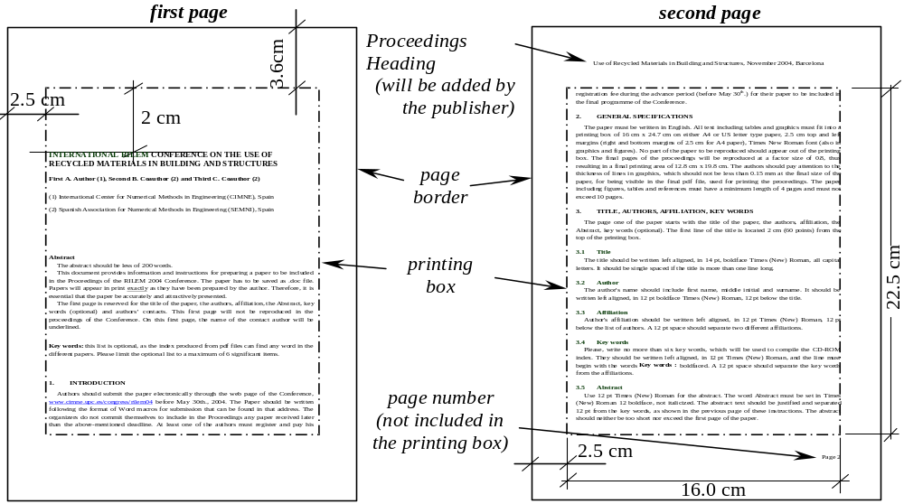
Figure 1: Page layout
A 6pt space should separate the figure from the caption, and a 12 pt space should separate the upper part of the figure and the bottom of the caption from the surrounding text.

10. Footnotes
Avoid footnotes if possible. If you must sparingly use them, please be sure that they are typed within the margins specified above.

11. Conclusions
- The final Paper should be submitted electronically, as Word document (.doc/.docx), through the website of paper submission system
http://grad.hr/rilem.smss/ocs/index.php/smss/smss
- The Paper should be written following the format of the Word template for submission that can be found in the address of the conference
http://grad.hr/rilem.smss/call-for-papers/#submit
- Deadline for the submission of the full paper is 1st October 2018
- The organizers do not commit themselves to include in the Proceedings any paper received later than the above-mentioned deadline
- At least one of the authors should register and pay the registration fee during the advance period (before 30th November 2018) for their paper to be included in the final program of the Congress and in the Proceeding.
- When sending your final paper to the Scientific Editors, be sure that you have sent back the RILEM Copyright form (available on the Web site http://grad.hr/rilem.smss/call-for-papers/#submit) duly filled with your handwritten signature (available on the site). Your paper cannot be published in the absence of this document.

ACKNowledgements
This optional heading should be inserted just before the References heading, both headings (Acknowledgements and References) being in bold Times New Roman 12 pt, without numbering.

References
- List and number all bibliographical references at the end of the paper under the major heading References. Number the references in order of appearance, using Times New Roman 11 pt. Authors are cautioned to give complete information about books and authors and to check spelling and dates carefully. The presentation of references is given below. Commercial papers or documents not available to the public cannot be referenced.
- Sterman, S. and Marsden, J.G., 'Silane coupling agents', Ind. Engng. Chem. 58 (3) (1966) 33-77.
- Alexander, K.M., Wardlow, J. and Gilbert, D., 'Aggregate-cement bond, cement paste strength and the strength of concrete', in 'The Structure of Concrete', Proceedings of an International Conference, London, September, 1965 (Cement and Concrete Association, London, 1968) 59-81.
- Crank, J., 'The Mathematics of Diffusion', 2nd Edn (Clarendon, Oxford, 1975).

Important note: Any paper received without the original licence duly completed cannot be reviewed for possible presentation during the conference and will not be included in the proceedings.

